***Muhammad Abdullah Kazmi***

***BSCS-6B***

***188990***

***LAB#07***

***COMPUTER NETWORKS***

***TASK 01:***

package javaapplication1;

/**

*

* @author mkazmi.bscs16seecs

*/

import java.sql.*;

import java.util.Scanner;

class JavaApplication1{

public static void main(String args[]){

try{

Class.forName("com.mysql.jdbc.Driver");

Connection con=DriverManager.getConnection(

"jdbc:mysql://localhost:3306/students","root","seecs@123");

Statement stmt=con.createStatement();

System.out.println("What action do you want to perform?\n");

System.out.println("1)Insert 2)Update 3)Delete\n");

Scanner sc = new Scanner(System.in);

int ans = sc.nextInt();

if(ans == 1){

boolean rs1=stmt.execute("INSERT INTO feeslip VALUES('3','Raeed', 'Asif', 'december', '12/11/2018')");

}

else if(ans == 2){

boolean rs2=stmt.execute("UPDATE feeslip SET firstname = 'Asim', lastname= 'Noor' WHERE regno = 1");

}

else if(ans == 3){

boolean rs3=stmt.execute("DELETE FROM feeslip WHERE firstname='Asim'");

}

ResultSet rs=stmt.executeQuery("select * from feeslip");

while(rs.next())

System.out.println(rs.getString(1)+" "+rs.getString(2)+" "+rs.getString(3)+ " "+rs.getString(4)+" "+rs.getString(5));

rs.close();

stmt.close();

con.close();

}catch(Exception e){ System.out.println(e);}

}

}

Inserting Records:

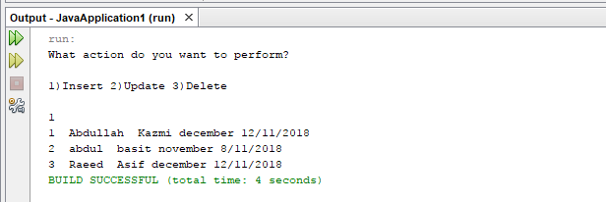

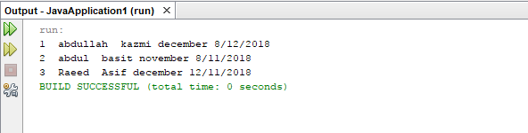

Updating Records:

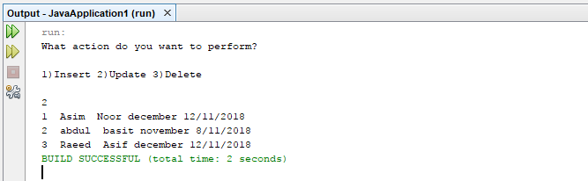

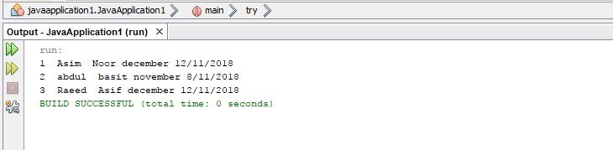

Deleting Records:

